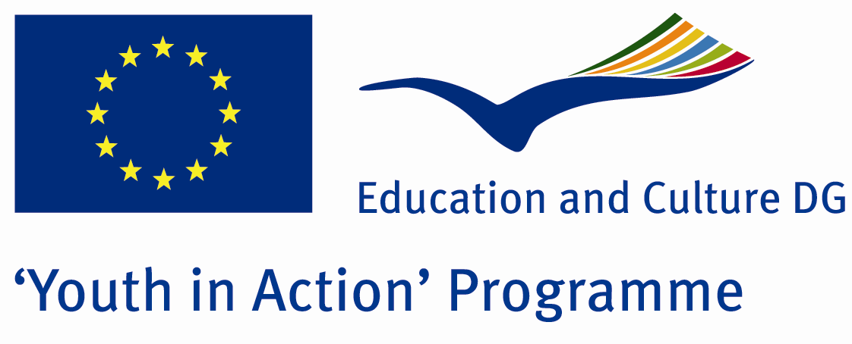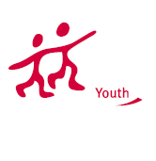

Inverted World



ACTION 1.1 – Youth Exchange

20-27th November , 2011

Mugla, TURKEY

Please contact directly to;
adventurerpeacepigeons@gmail.com

Project Summary;

Have you ever seen a woman who is driving a truck? Have you ever seen a woman who is beating his husband because he is not good at cooking? Have you ever seen a woman who was sexually arresting man because they did not wear in an appropriate form? Or, have you ever seen a man who is crying without thinking about what others think about him? Have you ever seen a man who is telling his deep feelings without being shy and getting judged by the others?

Answers of all such questions are related to social roles and gender. İn our project we will try to find answers to such questions.

If you want to join this project, please contact us..

Project Title; Inverted World

Date and Venue ; 20-27th November , 2011 Mugla, Turkey .

Target Group ; Municipalities, City Councils and Non-Governmental organizations,
youth groups,culture and art groups,e.t.c

Participants ; 5 people from each country (over 18 -25 ). Totally 8 countries.

Conditions ; Accommodation, board and programme costs will be financed through European Commission Youth in Action Programme . Travel costs will be reimbursed in 70% (APEX Tarrifs). Organizations from all 27 EU member countries plus Liechtenstein , Norway and Iceland are eligible to take part.

Working language: English

Organizer; Adventurer Peace Pigeons

How to apply: If you are interested, please send your Part III forms to
by e-mail please (in word file). Scan Part3 format is enough for application.(Fulfilled Part III which you can find in the attachment, of course signed and stamped) ..

Next step 2;
Original send via regular post to this address please:

Ertan DERİN
Fevzi Çakmak Mahallesi Tuncer Sokak No:6 PENDİK/İSTANBUL/TÜRKİYE
e-mail : adventurerpeacepigeons@gmail.com
Mobile : 0090 542 393 93 90

If you have any questions you may contact with: adventurerpeacepigeons@gmail.com

Deadline for application; until 15th may 2011.

For Further information:
Contact Person
Ertan DERİN
Fevzi Çakmak Mahallesi Tuncer Sokak No:6 PENDİK/İSTANBUL/TÜRKİYE
e-mail : adventurerpeacepigeons@gmail.com
Mobile : 0090 542 393 93 90

